CCNPv7.1 SWITCH – Case Study v3.1

1. Trunks and Port Channels

show interfaces trunk
show interfaces trunk
Native VLAN 800 and allowed VLANs confirmed across all trunk links.
DLS1  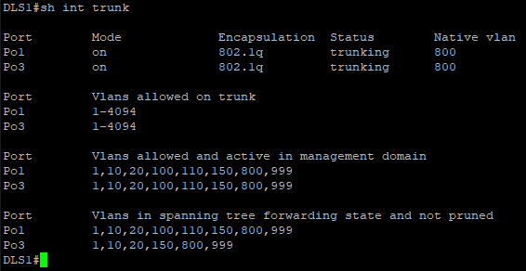 | DLS2  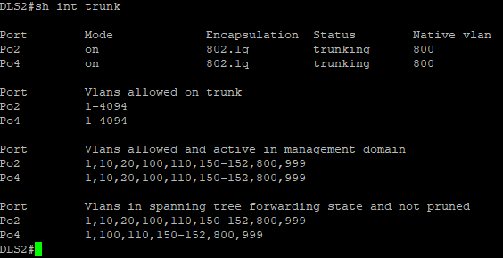
ALS1  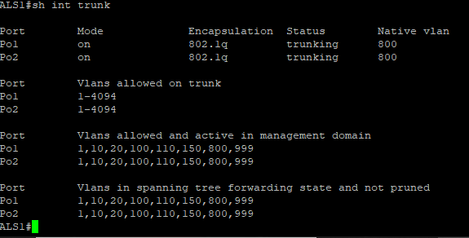 | ALS2  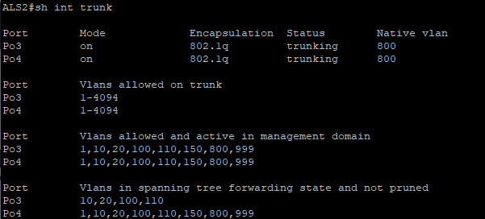

show etherchannel summary
show etherchannel summary
Po1 PAgP, Po2/Po3 Static, Po4 PAgP, Po10 LACP L3 all bundles active.
DLS1  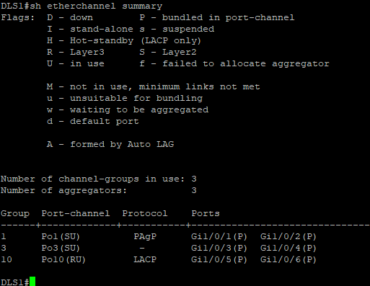 | DLS2  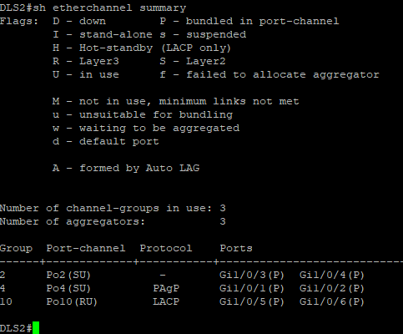
ALS1  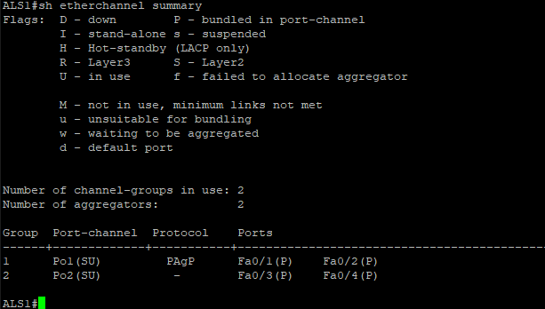 | ALS2  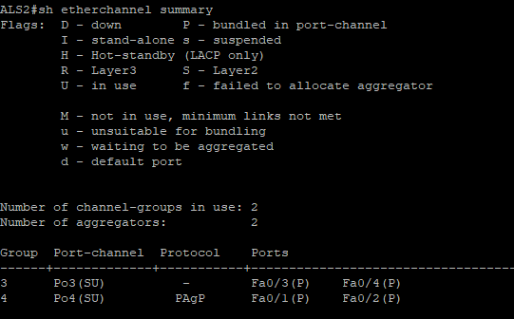

2. VTP

show vtp status
show vtp status
Domain CISCO, version 3, transparent mode on all switches.
DLS1  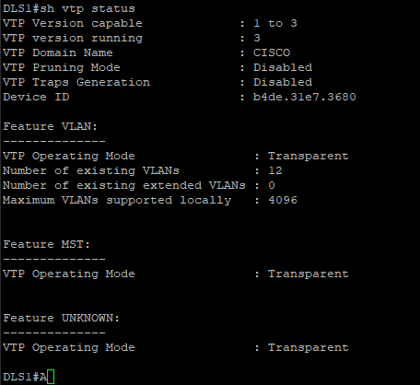 | DLS2  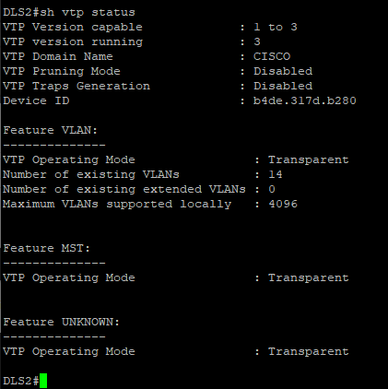
ALS1  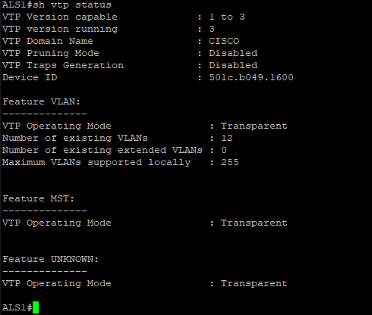 | ALS2  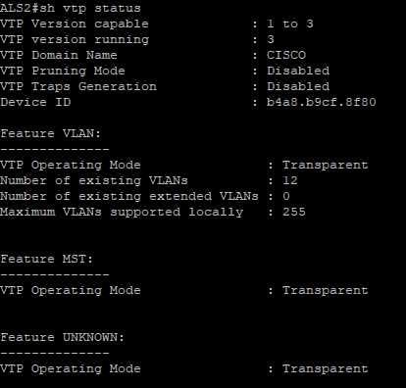

3. VLANs

show vlan brief
show vlan brief
VLANs 10,20,100,110,150,800,999 on all switches. DLS2 includes PVLANs 151 and 152.
DLS1  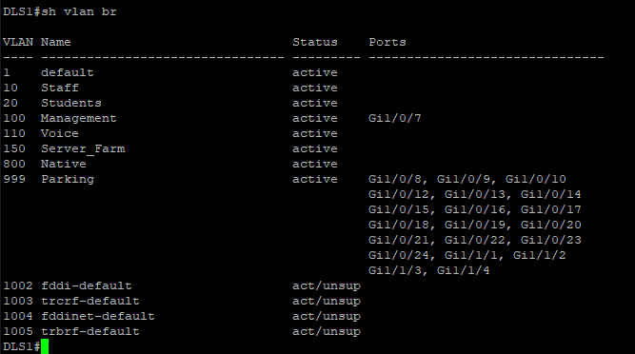 | DLS2  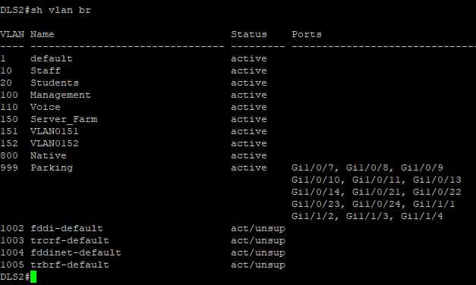
ALS1  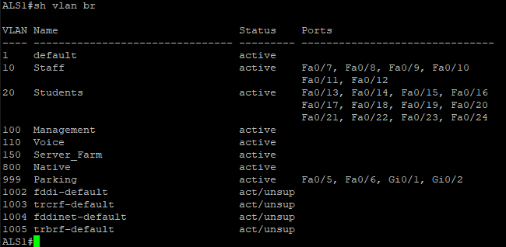 | ALS2  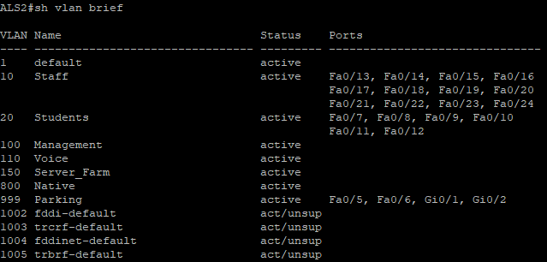

4. Spanning Tree (MST)

show spanning-tree mst configuration
show spanning-tree mst configuration
Identical region Region1 rev1 & Instance 1 (VLAN 10,20) Instance 2 (VLAN 100,110).
DLS1  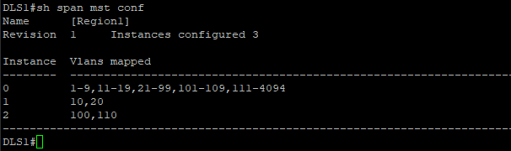 | DLS2  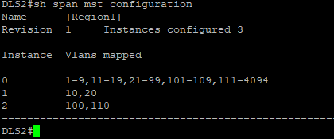
ALS1  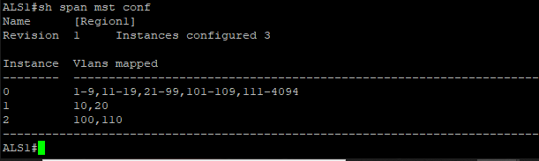 | ALS2  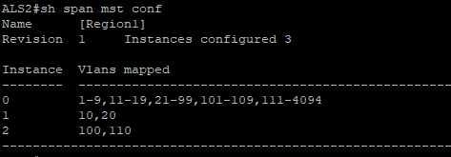

show spanning-tree root
show spanning-tree root
DLS1 root Instance 1. DLS2 root Instance 2.
DLS1  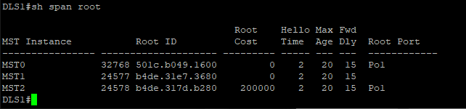 | DLS2  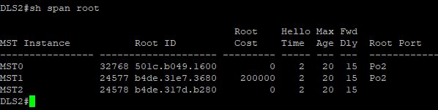
ALS1  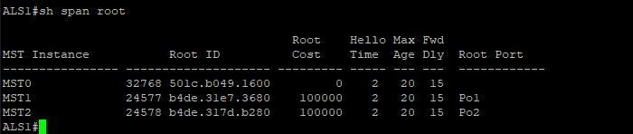 | ALS2  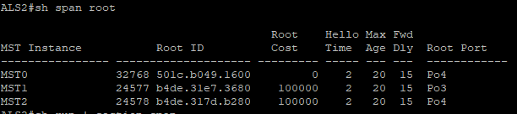

5. Spanning Tree Enhancements

show running-config | section span
show running-config | section span
PortFast and BPDUGuard on all access ports. MST priorities set.
DLS1  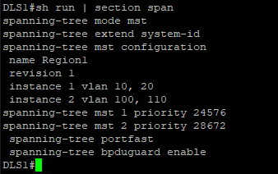 | DLS2  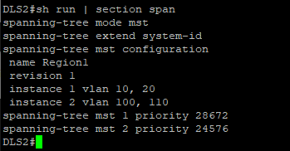
ALS1  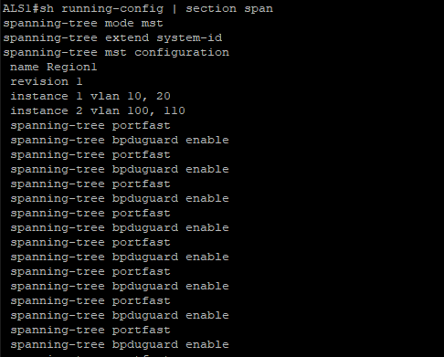 | ALS2  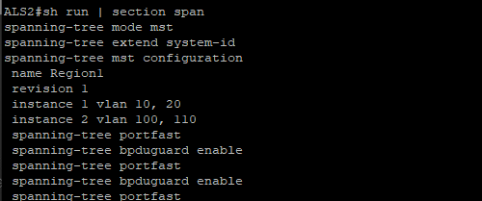

6. SVIs

show ip interface brief | exclude unassigned
show ip interface brief | exclude unassigned
All VLAN SVIs up/up on DLS switches. Vlan100 management SVI active on ALS switches.
DLS1  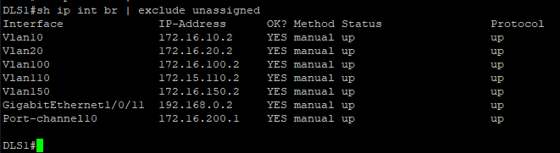 | DLS2  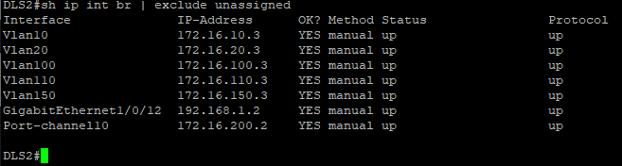
ALS1  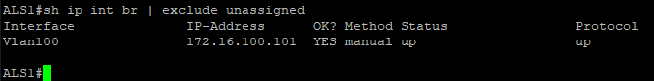 | ALS2

7. HSRP

show standby brief
show standby brief
DLS1 Active VLANs 10,20. DLS2 Active VLANs 100,110,150.
DLS1  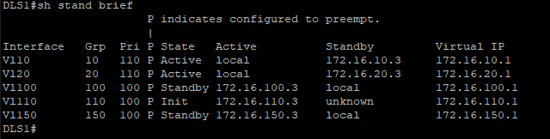 | DLS2  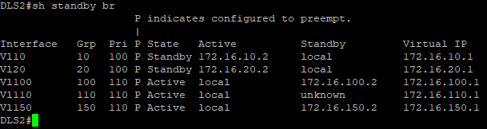

show running-config | section track
show running-config | section track
G1/0/11 tracked DLS1, G1/0/12 tracked DLS2 & decrement 20 on uplink failure.
DLS1  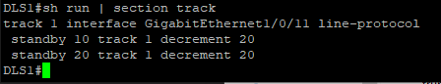 | DLS2  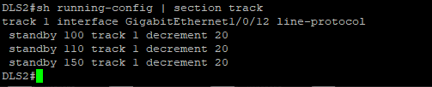

8. Routing

show ip route
show ip route
GATEWAY, DLS1, DLS2 showing full routing tables with EIGRP routes and default routes.

GATEWAY
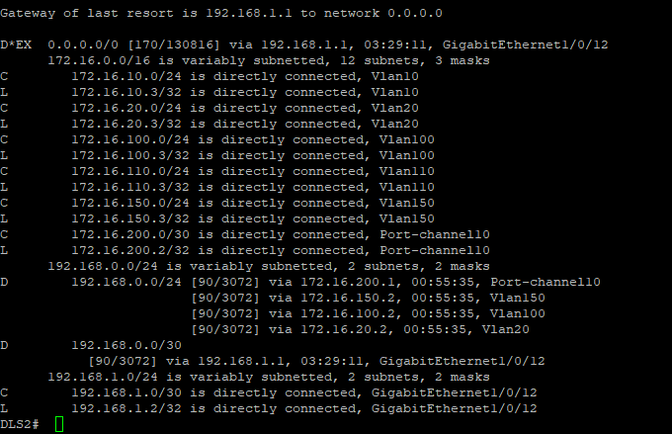
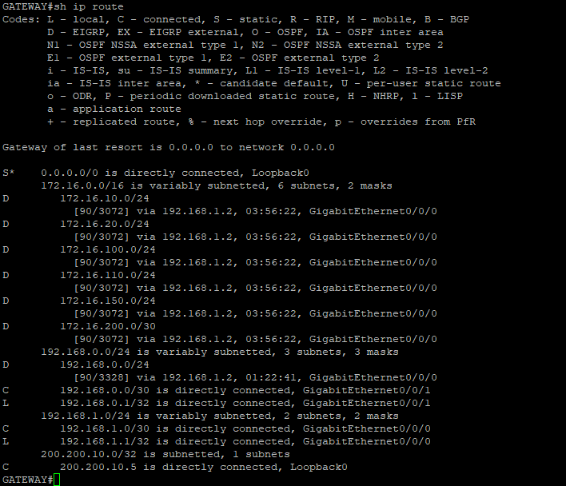
DLS1  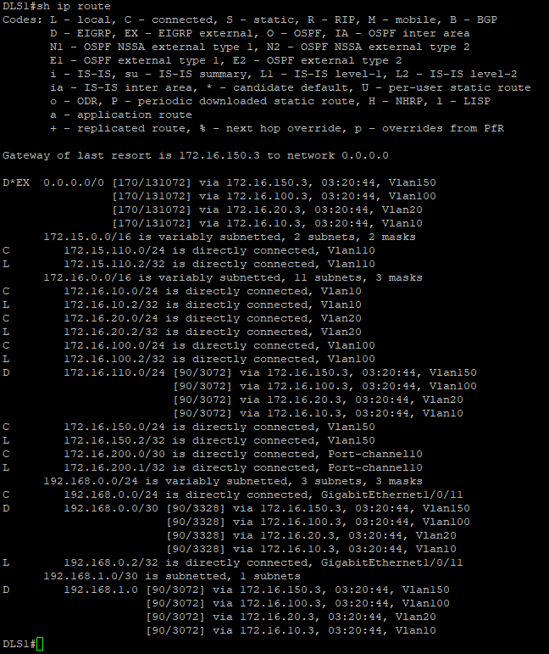 | DLS2

9. DHCP Snooping

show ip dhcp snooping
show ip dhcp snooping
Snooping on VLANs 10,20,100,110,150. Trunk ports trusted, access ports 15 pps.
ALS1  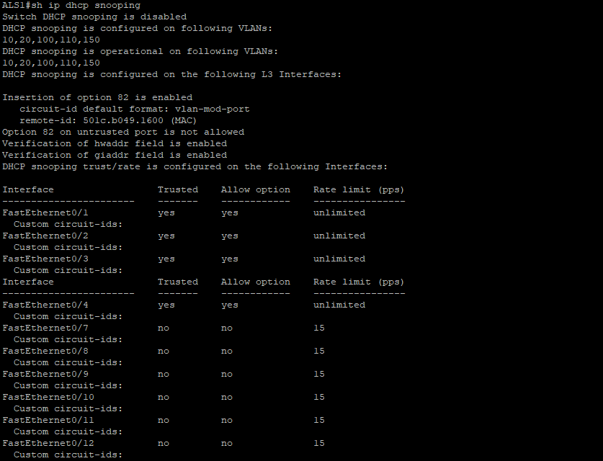 |  | ALS2  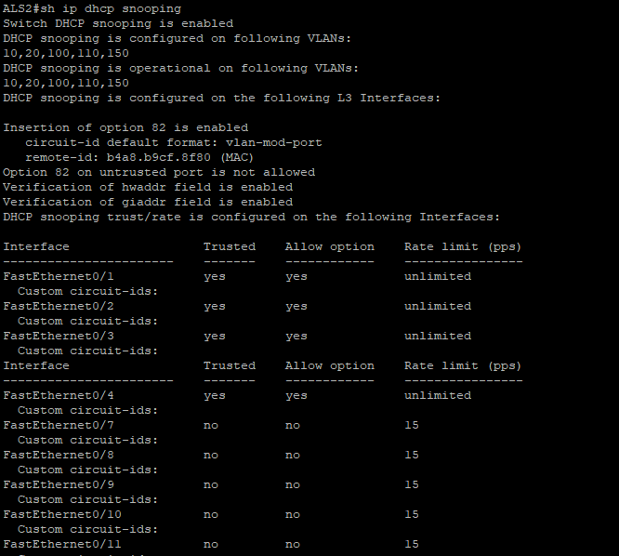

show running-config | section ip dhcp relay
show running-config | section ip dhcp relay
ip dhcp relay information trust-all on both DLS switches.
DLS1  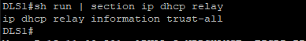 | DLS2  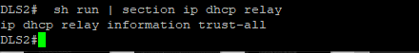

DHCP-SERVER Configuration
show running-config | section dhcp / interface / ip route
Pools for all VLANs. Interface 172.16.100.50. Default route via 172.16.100.2.
DHCP Pools  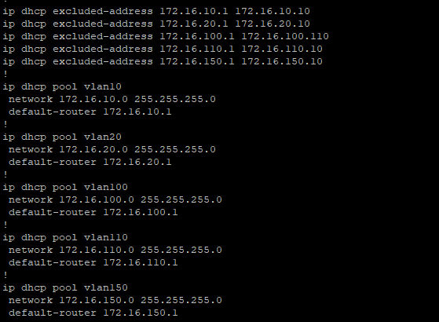 | Interface & Route  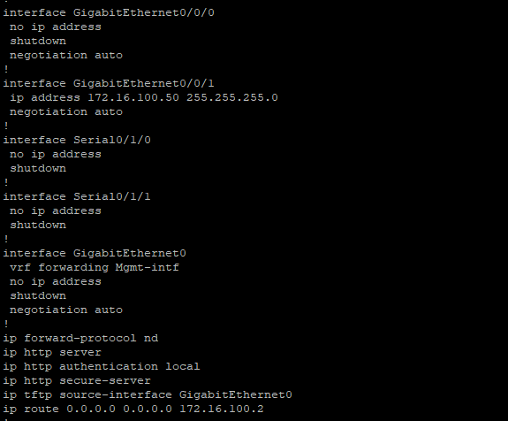

10. Port Security

show port-security
show port-security
ALS1 Fa0/13-24 max 3 MACs shutdown. ALS2 Fa0/18 static MAC 1234.1234.1234 protect.
ALS1  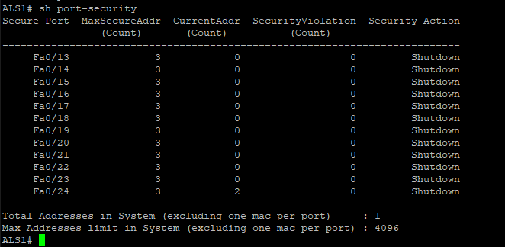 | ALS2  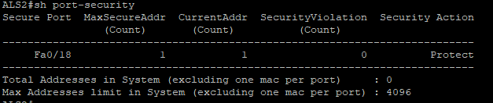

11. ACL – Staff and Student Separation

show access-lists
show access-lists
ACL 100 on DLS1 and DLS2 inbound Vlan20. ALS1 temp-host ACL for VACL.
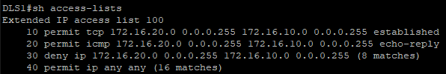  DLS1  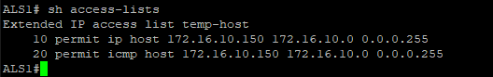  ALS1 | DLS2  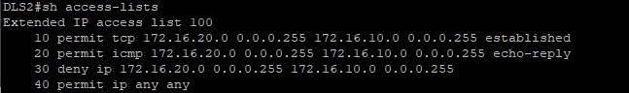

show ip interfaces | include line | list
show ip interfaces | include line | list
ACL 100 confirmed inbound on Vlan20 on both DLS switches.
DLS1  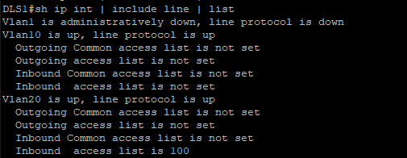 | DLS2  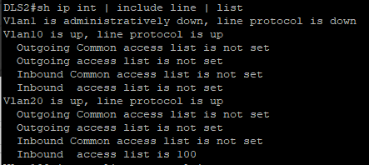

12. VACL – Temporary Staff Host

show vlan access-map / show vlan filter
show vlan access-map / show vlan filter
block-temp seq 10 drops 172.16.10.150 in VLAN 10, seq 20 forwards all other.
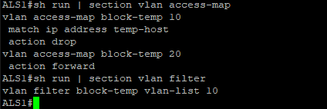

13. SSH

show ip ssh / show running-config | section line vty
show ip ssh / show running-config | section line vty
GATEWAY SSH v2 enabled. VTY lines SSH only with local auth.
show ip ssh  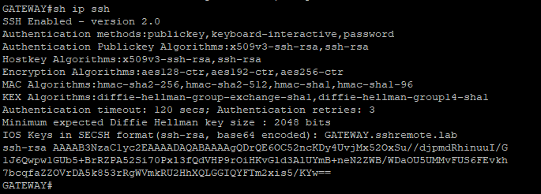 | section line vty  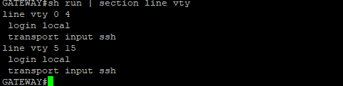

14. NTP

show ntp status
show ntp status
DLS1 master stratum 10. DLS2, ALS1, ALS2 synchronised to DLS1.
DLS1  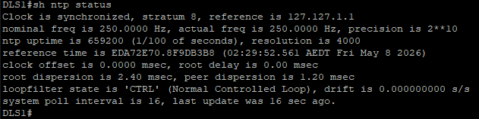 | DLS2  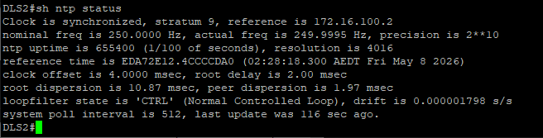
ALS1  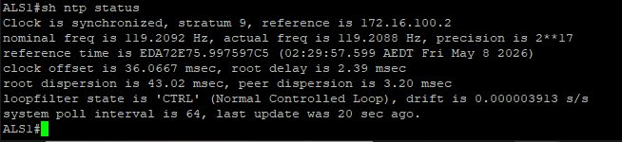 | 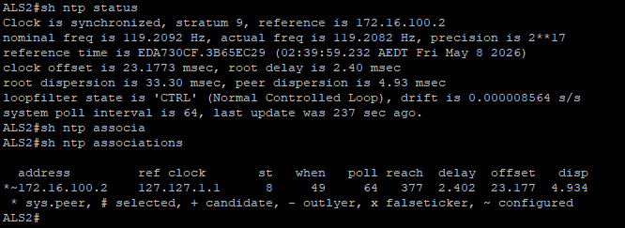  ALS2

show ntp associations
show ntp associations
All switches peering correctly with DLS1 NTP master.
DLS1  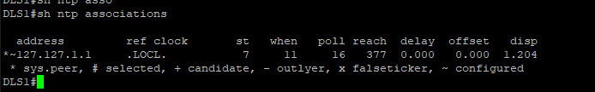 | DLS2  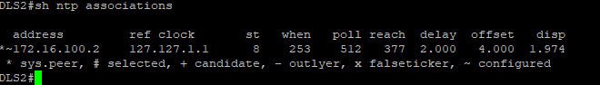
ALS1  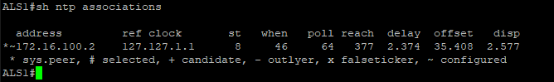 | ALS2  

15. Private VLANs

show vlan private-vlan / show vlan private-vlan type
show vlan private-vlan / show vlan private-vlan type
VLAN 150 primary, 151 isolated (G1/0/15-17), 152 community (G1/0/18-20) on DLS2.
show vlan private-vlan  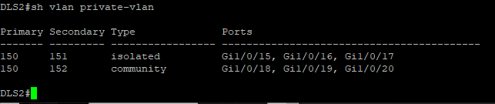 | show vlan private-vlan type  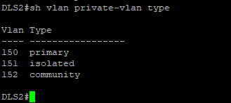

16. Test Connectivity to Internet

ping 200.200.10.5
ping 200.200.10.5
ALS1 and ALS2 pinging GATEWAY Loopback0 & full end-to-end routing confirmed.
ALS1  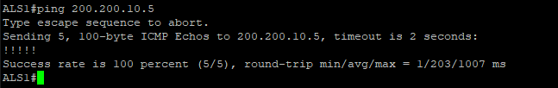 | ALS2  